一、下载以及安装android studio和ndk
网址：http://www.androiddevtools.cn/
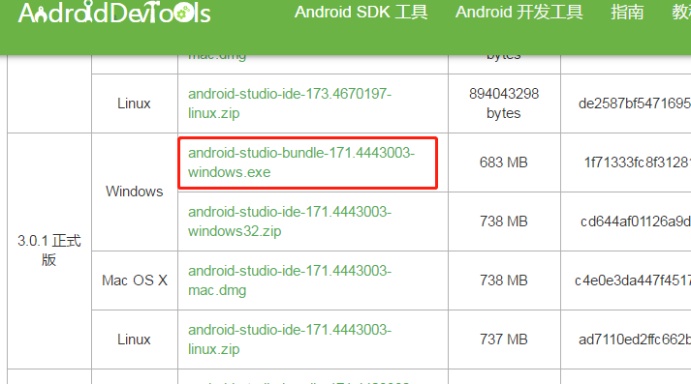
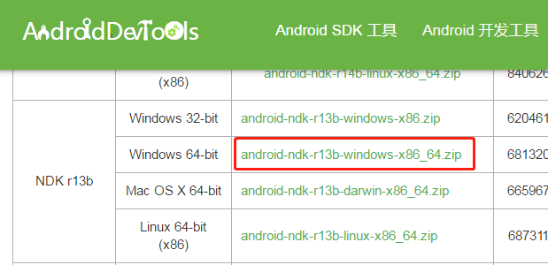

ndk解压到本地路径F:\android\android-ndk-r13b
android studio安装路径 C:\Program Files\Android\Android Studio

下载API 27版本SDK
打开file->setting，下载SDK
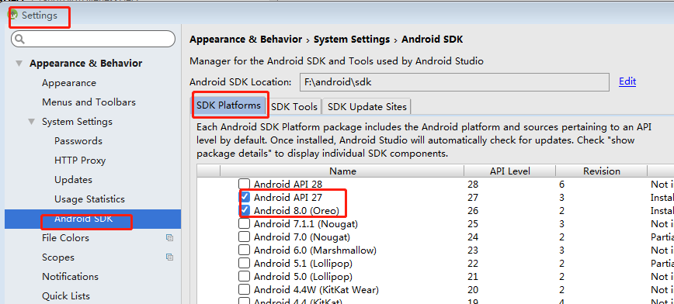

注意 下面3个步骤为了下安装SDK
1、选sdk manager
2、选择路径下载android ask
3、API27，点apply，让IDE配置完成

SDK本地路径F:\android\sdk

配置ndk和sdk路径，运行hello world
打开file->project structure，配置ndk和sdk，jdk是as自带的不需要自己下载
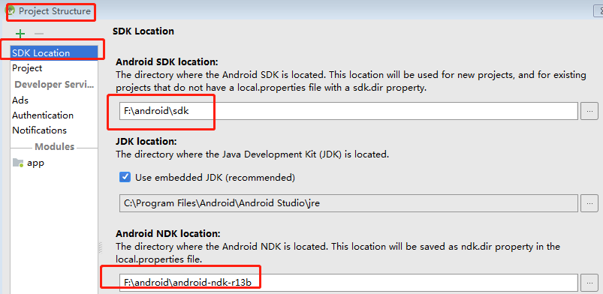

其他步骤参考
https://jingyan.baidu.com/article/49ad8bce9e8f9d5834d8fabd.html

四、遇到的其他问题
unable to access android sdk-on list
https://blog.csdn.net/qq_33721320/article/details/74451397

Execution failed for task ':app:preDebugAndroidTestBuild'.
https://stackoverflow.com/questions/50089436/errorexecution-failed-for-task-apppredebugandroidtestbuild-when-tried-to

Error:Unable to get the CMake version located
https://jingyan.baidu.com/article/219f4bf78d5ad8de442d388b.html

error initializing adb:android debug bridge not found

adb server version (31) doesn't match this client
https://www.aliyun.com/jiaocheng/28053.html
https://blog.csdn.net/laofashi2015/article/details/80563357
netstat -ano | findstr "5037"

file was load in wrong encoding :utf-8
https://blog.csdn.net/qq_33210042/article/details/78559867

[Android Pro] Android studio jni中调用Log输出调试信息
https://www.cnblogs.com/0616--ataozhijia/p/5628291.html

